PYSPARK RDD USING DATABRICKS
Set-up DataBricks:
- Sign up to Databricks community free edition portal
Upload file:
- Go to catalog and open add data. Browse files and select the file from internal device.
- Choose destination of the file. Put workspace as Default, and create a volume named “My_volume” by default it is managed volume and upload it.
- The file will be uploaded and copy the file path.
- You can verify the uploaded file: catalog workspace default volume you can find the uploaded file.
Write and run queries:
- Goto notebook and set the language to Python.
- Write and run the queries.

- Import spark libraries
- Convert csv file to text file
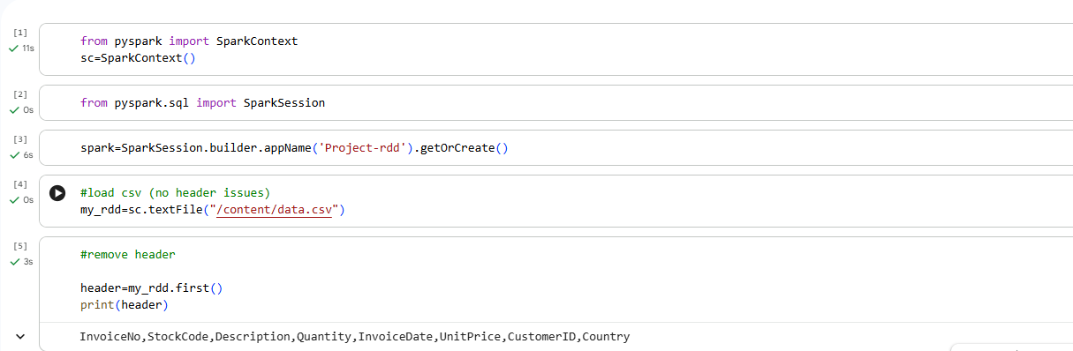
- Remove header

- Split the data
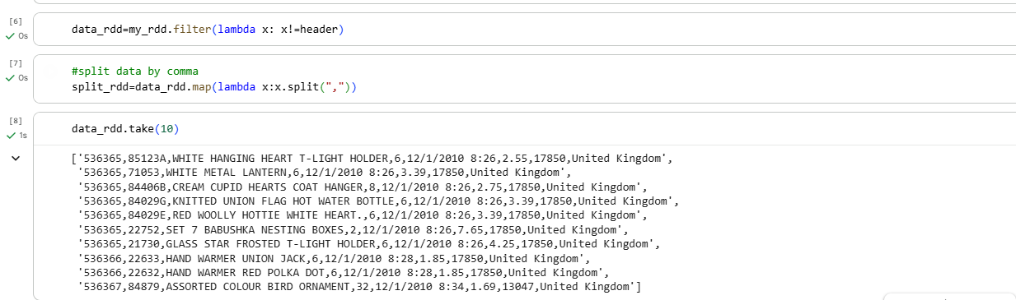

- Indexing the columns
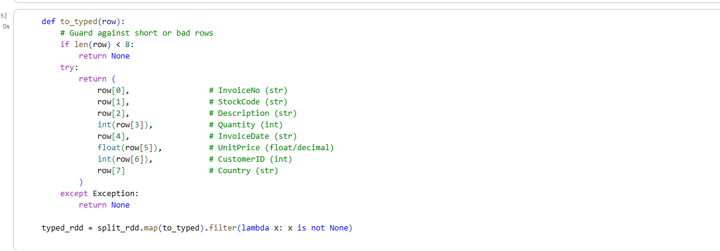

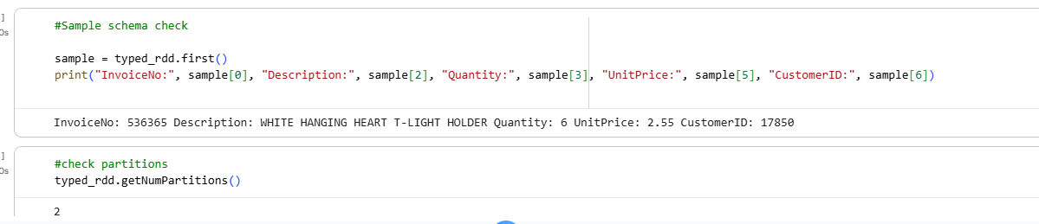
- Sample schema check

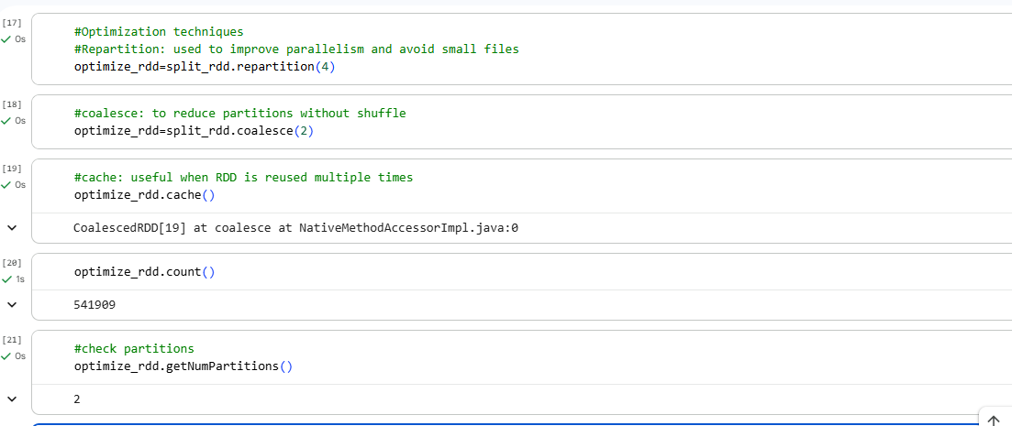
- Optimization techniques

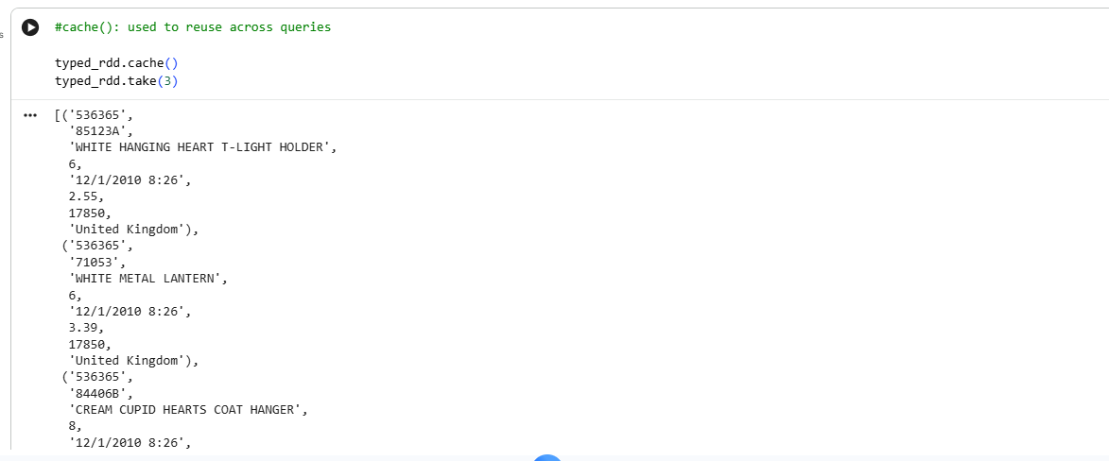

- Query 1- unit price of each customer
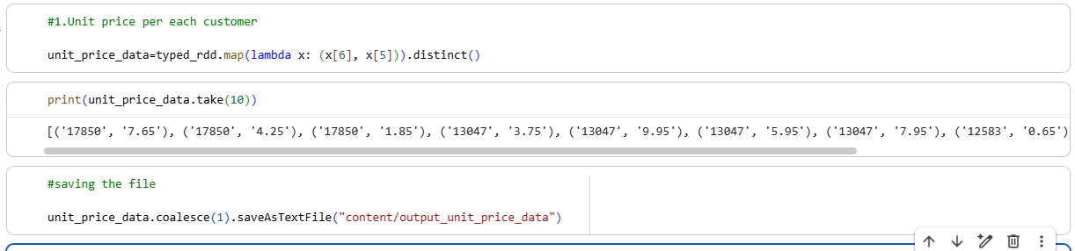

- Query2- Average unit price per customer
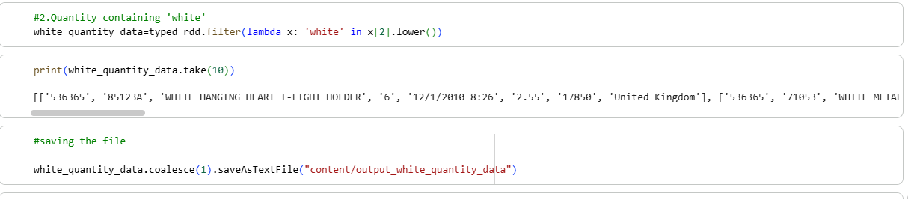

- Query 3- Display data description that contains ‘white’
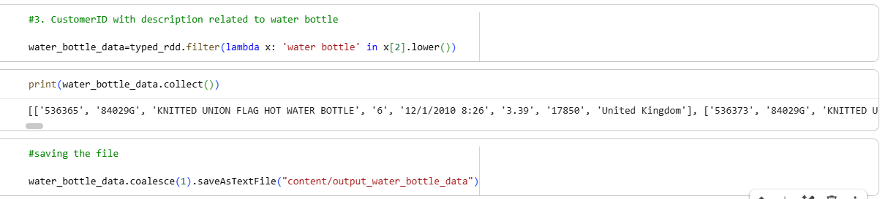

BI reports on the above business queries
- unit price of each customer
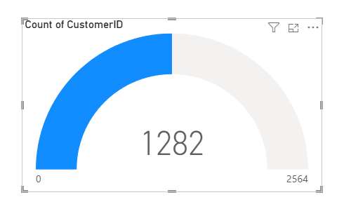

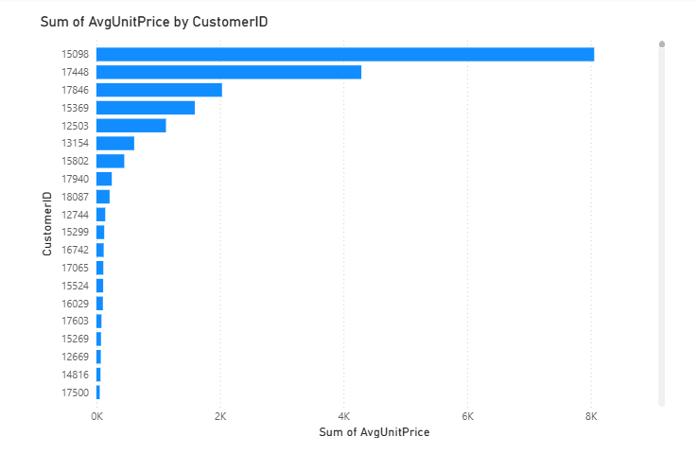
- Average unit price per customer

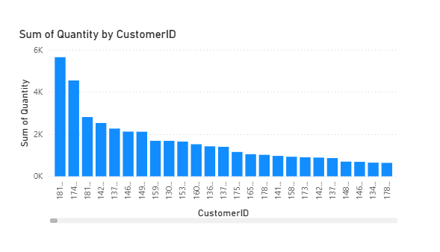
- Display data description that contains ‘white’

NIFI

- Download Nifi. Copy the path up to bin and run the following steps in cmd
- cd C:\Users\VS001088966\Downloads\nifi-1.28.1-bin\nifi-1.28.1\bin
dir - check files (optional)
run-nifi.bat
status-nifi.bat
https://localhost:8443
Nifi port number: 8443
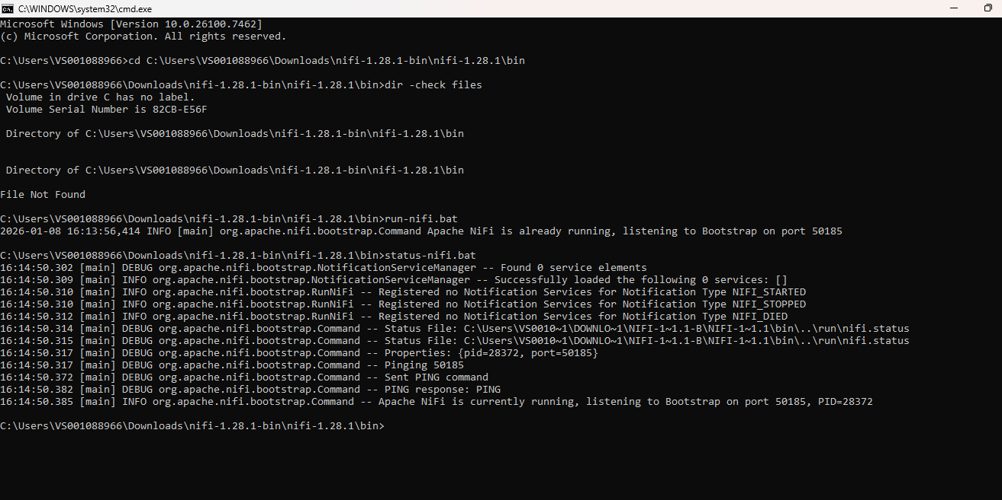

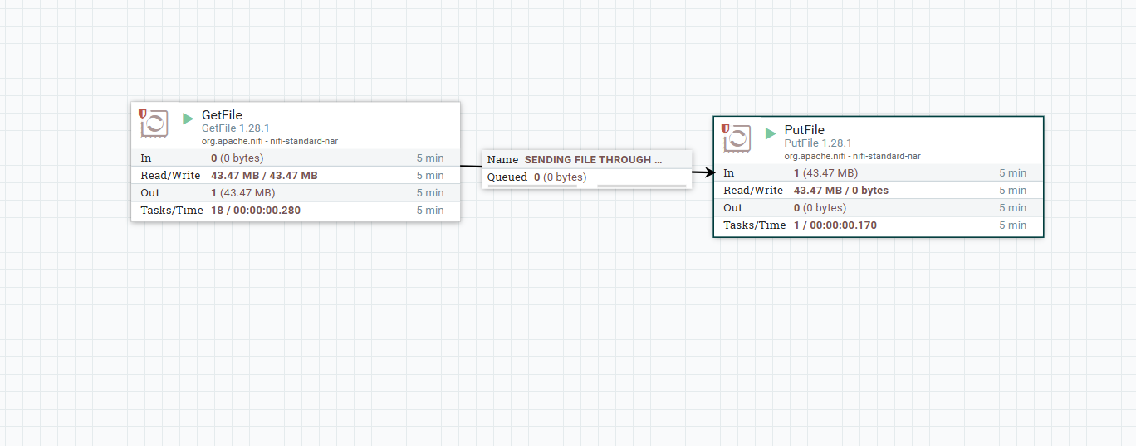
Flow 1: GetFile → PutFile (local move)

GetFile to PutFile queue
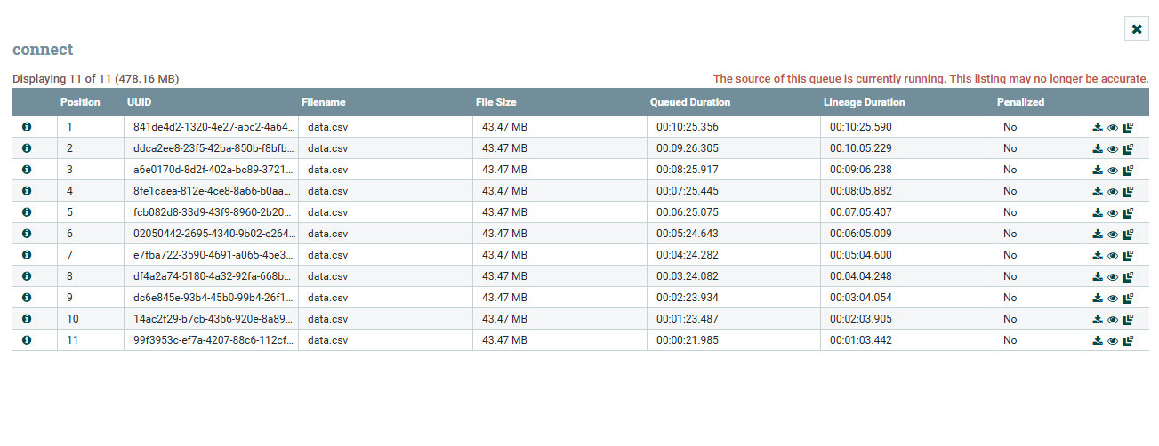

Flow 2: GetFile → HDFS (batch ingestion)

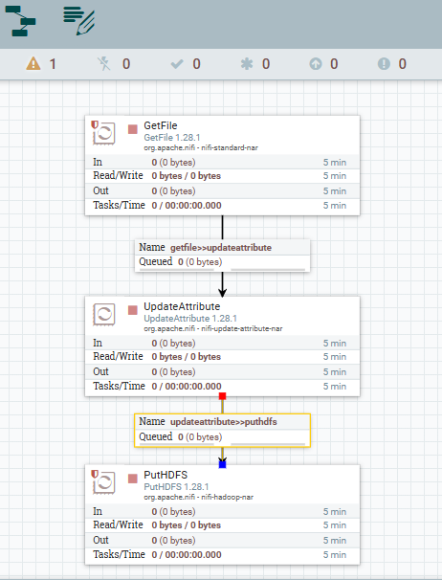

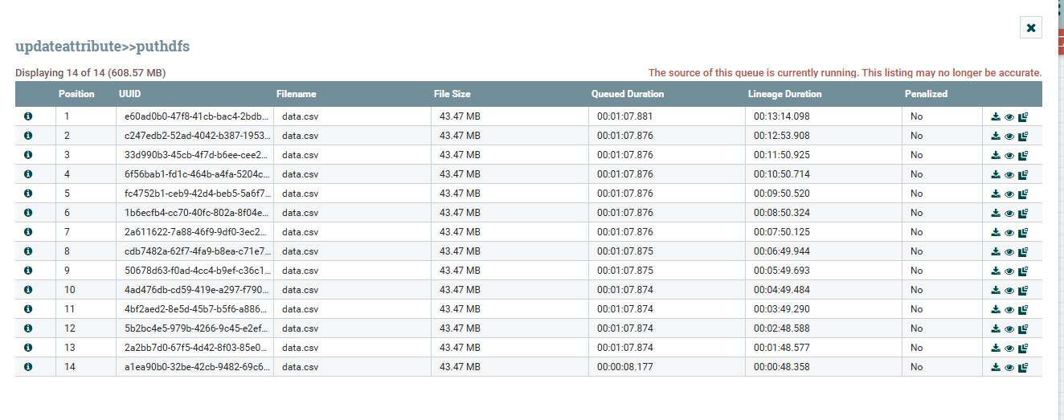
GetFile to HDFS queue

Flow 3: InvokeHTTP → HDFS (API ingestion).
